Project Planning Phase
Project Planning Template (Product Backlog, Sprint Planning, Stories, Story points)

Date | 15 February 2025
Team ID | LTVIP2026TMIDS42870
Project Name | electric motor temperature prediction using machine learning
Maximum Marks | 5 Marks

Product Backlog, Sprint Schedule, and Estimation (4 Marks)
Use the below template to create product backlog and sprint schedule
Sprint | Functional Requirement (Epic) | User Story Number | User Story / Task | Story Points | Priority | Team Members
Sprint-1 | Data preparation | USN-1 | As a data scientist, I want to generate a synthetic dataset of motor parameters so that I have data for model training. | 3 | High | Data Team
Sprint-1 |  | USN-2 | As a data scientist, I want to explore the dataset (statistics, distributions) to understand the data characteristics | 1 | High | Data Team
Sprint-2 |  | USN-3 | As a data scientist, I want to split the data into training (80%) and testing (20%) sets for model validation. | 2 | Low | Data Team
Sprint-1 | Model Development | USN-4 | As a data scientist, I want to implement feature scaling using StandardScaler to normalize input features. | 2 | Medium | ML Team
Sprint-1 | Web Application - Main App | USN-5 | As a developer, I want to set up a Flask application structure with templates folder. | 2 | High | ML Team

Project Tracker, Velocity & Burndown Chart: (4 Marks)
Sprint | Total Story Points | Duration | Sprint Start Date | Sprint End Date (Planned) | Story Points Completed (as on Planned End Date) | Sprint Release Date (Actual)
Sprint-1 | 7 | 5 Days | 24 dec 2025 | 29 jan 2025 | 7 | 29 dec 2025
Sprint-2 | 14 | 7 Days | 31 dec 2025 | 05 dec 2025 | 14 | 02 dec 2025
Sprint-3 | 16 | 7 Days | 07 jan 2026 | 12 jan 2026 | 16 | 09 dec 2025
Sprint-4 | 13 | 6 Days | 14 jan 2026 | 19 jan 2026 | 13 | 15 jan 2026
Sprint -5 | 9 | 5 Days | 16 jan 2026 | 20 jan 2026 | 9 | 18 jan 2026
Sprint-6 | 12 | 6 Days | 21 jan 2026 | 24 jan 2026 | 12 | 26 jan 2026
Velocity:
Imagine we have a 10-day sprint duration, and the velocity of the team is 20 (points per sprint). Let’s calculate the team’s average velocity (AV) per iteration unit (story points per day)
Sprint | Story Points Completed | Duration (Days) | Velocity (Points/Day)
Sprint-1 | 7 | 5 | 1.40
Sprint-2 | 14 | 7 | 2.00
Sprint-3 | 16 | 7 | 2.29
Sprint-4 | 13 | 6 | 2.17
Sprint-5 | 9 | 5 | 1.80
Sprint-6 | 12 | 6 | 2.00
Sprint-7 | 11 | 5 | 2.20
Sprint-8 | 13 | 6 | 2.17

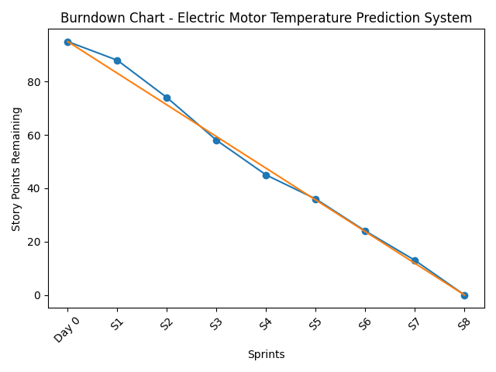
Burndown Chart:
A burn down chart is a graphical representation of work left to do versus time. It is often used in agile software development methodologies such as Scrum. However, burn down charts can be applied to any project containing measurable progress over time.
Reference:
Atlassian Agile Project Management
Scrum with Jira Software
Epics, Stories, and Themes
Sprint Planning

